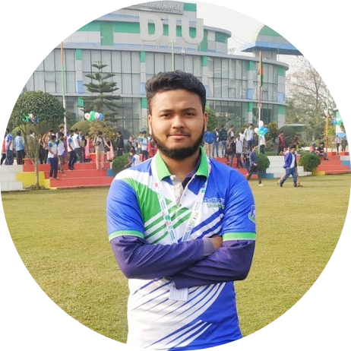

ABU NAIIM

Full Stack Web Developer

[abu15-13860@diu.edu.bd](mailto:abu15-13860@diu.edu.bd)

**Address**:

Model Town, Keranigong, Dhaka, Bangladesh.

**GitHub:** [**abunaiim25**](https://github.com/abunaiim25)

**Linked In:** [**abunaiim**](https://www.linkedin.com/in/abu-naiim-516949210/)

Phone: 01316057864

# CAREER OBJECTIVE

To work in the software department of various private or public firms in Bangladesh, and to advance quickly with growing responsibilities.

# PERSONAL INFORMATION:

* **Full Name:** Abu Naiim Md. Rayhan Siddique .
* **Father’s Name:** Dr. Md. Abu Baker Siddique.
* **Mother’s Name:** Naiima Siddika.
* **Date of Birth:** 03.07.2000.
* **Material Status:** Single.
* **National Id No:** 691 254 1858.
* **Religion:** Islam.
* **Present Address:** Keraniganj, Dhaka.
* **Permanent Address:** Chandpur.

# TECHNICAL SKILLS:

* **Programming Skills:** C, Java, Python, PHP, JavaScript.
* **Web Coding Skills:** HTML, CSS, Bootstrap, JavaScript, React.js, Laravel (PHP).
* **Mobile Platform:** Android Development (Java).
* **Database Management:** MySQL, Firebase.
* **Version Control:** Git & GitHub.
* **Office Tools:** Word, PowerPoint, Google Docs (Docs, Sheets, Slides).
* **Others:** UI/UX design, LaTex.

# EDUCATIONAL QUALIFICATION

## Bachelor of Science in Computer Science & Engineering (B.Sc. in CSE)

University : Daffodil International University.

Passing Year : 2023.

Result : 3.66 out of 4.00 (Average of 7 Semesters).

## Higher Secondary School Certificate (Alim)

Madrasah : Darunnazat Siddique Kamil Madrasah.

Group : Science.

Passing Year : 2019.

Result : 4.69 out of 5.00.

## Secondary School Certificate (Dakhil)

Madrasah : Hafez Abdur Razzak Jamia Islamia Madrasah.

Group : Science.

Passing Year : 2017.

Result : 5.00 out of 5.00.

## Junior School Certificate (JDC)

Madrasah : Hafez Abdur Razzak Jamia Islamia Madrasah.

Passing Year : 2014.

Result : 5.00 out of 5.00.

# PROJECT:

### [Hospital Management System (Web)](https://github.com/abunaiim25/Hospital-Management-System-Laravel)

**Platform:** HTML, CSS, Bootstrap, JavaScript, Laravel (PHP), MySQL.

### AgroBd (Web)

**Platform:** HTML, CSS, Bootstrap, JavaScript, Laravel (PHP), MySQL.

### [Mobile Shop (Web)](https://github.com/abunaiim25/MobileShop-Laravel-web)

**Platform:** HTML, CSS, Bootstrap, JavaScript, Laravel (PHP), MySQL.

### [Portfolio Abu Naiim (Web)](https://github.com/abunaiim25/AbuNaiim-Personal-Laravel-web)

**Platform:** HTML, CSS, Bootstrap, JavaScript, Laravel (PHP), MySQL.

### [TV & News Paper (Android App)](https://github.com/abunaiim25/TV-NewsPaper-Android-App)

**Platform:** XML, Java.

# PROBLEM SOLVING:

* **URI Online Judge:** 150+ solved.
* **Local:** 100+ solved.

# ACHIEVEMENT:

* Solved more than 150+ problems in various online judges.
* Participated in ICPC 2021 (The International Collegiate Programming Contest) Dhaka Regional contest.

# EXPERIENCE:

* Working at DIU CPC (Daffodil International University Computer Programming Club.
* I have been doing freelancing more than 1.5 years by web development (PHP Laravel).

# OTHER SKILLS:

* **Languages:** English (Full working knowledge) and Bangla (Fluent).
* **Writing:** Experienced in writing technical articles in English and Bangla.
* **Activities:** Volunteer Work and Community Service.

# PUBLICATION:

Using social media applications for educational outcomes in college teaching:

A structural equation analysis (Oct 11, 2021)

# REFERENCE:

MD. HAFIZUR RAHMAN ARFIN,

Lecturer, Programmer and Researcher,

CSE, Daffodil International University,

Email: arfin97@gmail.com.